**DATA BINDING**

**Enlace: ->** [**https://www.youtube.com/watch?v=9sVJvjxHzdY**](https://www.youtube.com/watch?v=9sVJvjxHzdY)

1.

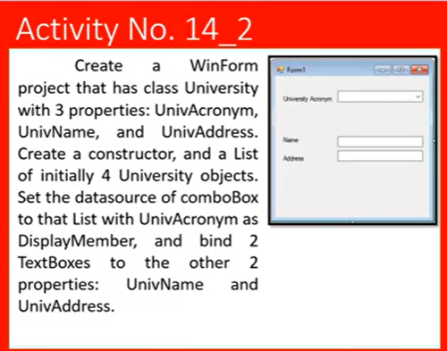2.

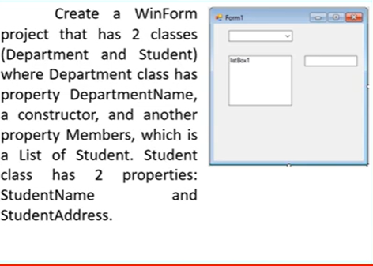3.

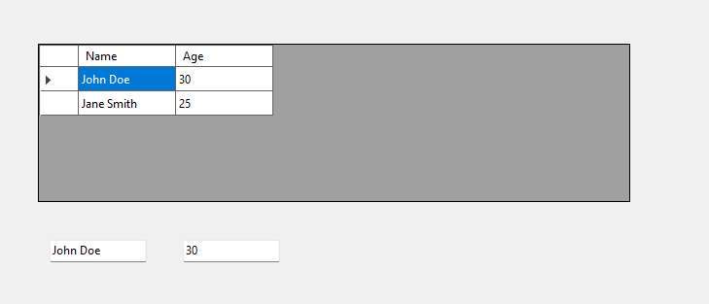4.